**About your Self:**

Hi, Myself Barkavi from Chennai. Currently, I have been working as Junior- Quality Analyst in Solvedge Tech private limited. I have 5 years of experience in manual testing and worked on multiple projects involving web and mobile based applications. And I am working on health care domain.

**Why are you looking for a change?**

To make use of better opportunities to learn as well as to grow professionally. Also, for the financial gain as well.

Role of your Position:

* Analyzing the user requirement.
* Identifying the test scenarios and preparing the test cases.
* Executing various testing phases like functional, integration, Retesting, smoke testing.
* Updating issues in the defect tracking tool and following the issues.
* User Acceptance testing and making reports.

**Project Details:**

**Recovery Coach:**

Recovery coach is our project and it is health care application which is web and mobile based application.

In that application will guide the patients entire surgical journey that is before and after surgery.

The application was classified into two portals one is for patients and other one for hospital staff like surgeon, Nurse, Care navigator etc.

At first stage care navigators will add patients either before and after surgery. Hospital staff will track the patient up to one year from the date of surgery.

Care navigators will track the patients in 4 different stages.

If the patient doesn’t have any surgery date they will fall under

* Non-Surgical stage.

If the patients have surgery date in future, they will fall under

* Preparing for surgery

If the patients have surgery date is in past that is they complete their surgery, they will fall under

* Recovery

If the patient’s surgery was completed 90 days before that is in past they will fall under

* Follow up and progress

CC/CN will provide document, Exercise Videos and surveys for each and very stages which the patients have to follow and complete it.

CC/CN will send notification and appointments remainders for patients.

**Black box testing**

It is testing process to check the functionalities of the software application by using testing types called functional testing, system testing, Regression testing and integration testing.

**Functional Testing**

It is testing process to check the functionalities of the software application as per the client requirement.

**Regression testing**

Re-executing the old test cases in order to ensure that newly added feature or functionalities is not causing any impact in the old feature or old functionalities.

**integration testing**

Combining the two modules and checking the data flow in between the two modules.

**Unit Testing?**

It is testing process performed by developer before releasing the software application to QA team.

**Smoke Testing?**

It is the initial testing process in order to find any blocker or show stoppers in the software application when the build is deployed to QA environment and also it verifies whether the software build is working as expected.

**Sanity Testing?**

It is detailed testing process to check the functionalities bugs when there is any code changes or any functionalities change in software application.

**Exploratory Testing?**

It is a testing process where test cases are not created in advance but checking the system on the flow.

* Functionalities are checked in adhoc manner
* Widely used in agile methodology.

**User Acceptance Testing?**

It is a testing process performed by the client to verify the software requirement before moving the application to the production environment.

* UAT is done in the final phase after integration, functional etc.
* Main purpose of UAT is to validate end-to-end business flow.

**STLC (Software testing life cycle)**

**Analyzing the requirement**

* Analyses business functionality to know the business modules and module specific functionalities.
* Identify all transactions in the modules.
* Identify all the user profiles.
* Gather user interface/ authentication, geographic spread requirements.
* Identify types of tests to be performed.
* Gather details about testing priorities and focus.
* Prepare Requirement Traceability Matrix (RTM).
* Identify test environment details where testing is supposed to be carried out.
* Automation feasibility analysis (if required).

**Test Planning**

* Analyze various testing approaches available
* Finalize on the best-suited approach
* Preparation of test plan/strategy document for various types of testing
* Test tool selection
* Test effort estimation
* Resource planning and determining roles and responsibilities.

**Preparing test cases**

* Create test cases, test design, automation scripts (where applicable)
* Review and baseline test cases and scripts
* Create test data
* Reviewed and signed test Cases/scripts
* Reviewed and signed test data

**Test environment**

* Understand the required architecture, environment set-up
* Prepare hardware and software development requirement list
* Finalize connectivity requirements
* Prepare environment setup checklist
* Setup test Environment and test data
* Perform smoke test on the build
* Accept/reject the build depending on smoke test result

**Test execution**

* Execute test cases as per plan
* Document test results, and log defects for failed cases
* Update test plans/test cases, if necessary
* Map defects to test cases in RTM
* Retest the defect fixes
* Regression Testing of application
* Track the defects to closure

**Test closer**

* Evaluate cycle completion criteria based on – Time, Test coverage, Cost, Software Quality, Critical Business Objectives
* Prepare test metrics based on the above parameters.
* Document the learning out of the project
* Prepare Test closure report
* Qualitative and quantitative reporting of quality of the work product to the customer.
* Test result analysis to find out the defect distribution by type and severity

**SDLC (Software Development life cycle)**

Phase 1: Requirement collection and analysis

Phase 2: Feasibility study

Phase 3: Design

Phase 4: Coding

Phase 5: Testing

Phase 6: Installation/Deployment

Phase 7: Maintenance

**Blackbox Technique**

1. Error Guessing
2. Equivalence Partitioning
3. Boundary value analysis

**Agile Ceremonies**

Sprint Planning

Daily scrum

Sprint review

Sprint Retrospective.

**What is Sprint Retrospective?**

An agile retrospective, or sprint retrospective as Scrum calls it, is a practice used by teams to **reflect on their way of working, and to continuously become better in what they do**.

**What is agile?**

It is software development methodologies where the requirements are delivered incrementally instead of all at once.

**What is scrum or scrum process?**

It is the process of meeting in which the team members describe about

* What they have done since last scrum meeting
* What they plan to do before the next meeting.
* Also, they discuss about the issues that need to be resolved.

**What are Scrum roles?**

* Scrum master
* The product owner.
* The team members (QA team and dev team)

**Scrum master roles and responsibilities?**

* Daily scrum meeting
* Iteration/sprint plan meeting
* Clearing doubts or blockers if there are any doubts regarding the requirements.
* Establishing the environment in which the team can be effective.
* Maintaining good relationship between team and product owner.

**What is sprint?**

Within the time iteration, planned amount of work has to be completed by the team and made ready.

**What is Iteration?**

In scrum, iterations are called sprints and may be 1 to 2 weeks. In this iteration (Analysis, design, development, testing everything will be completed.)

Question: What is the iteration time period in your office (ANS: 1 to 2 Weeks)

**system testing**

It is a testing process performed to evaluate the completed system compliance against specified requirement in system testing the functionalities of the system are tested from an end-to-end perspective.

**Defect life cycle**

New

Assigned(open)-→Rejected, duplicate, deferred, not an issue

Fixed (Retest pending)

**Reopen**

Verified (Closed)

**New** - Potential defect that is raised and yet to be validated.

**Assigned** - Assigned against a development team to address it but not yet resolved.

**Active** - The Defect is being addressed by the developer and investigation is under progress. At this stage there are two possible outcomes; viz - Deferred or Rejected.

**Test** - The Defect is fixed and ready for testing.

**Verified** - The Defect that is retested and the test has been verified by QA.

**Closed** - The final state of the defect that can be closed after the QA retesting or can be closed if the defect is duplicate or considered as NOT a defect.

**Reopened** - When the defect is NOT fixed, QA reopens/reactivates the defect.

**Deferred** - When a defect cannot be addressed in that particular cycle it is deferred to future release.

**Rejected** - A defect can be rejected for any of the 3 reasons; viz - duplicate defect, NOT a Defect, Non Reproducible.

**RTM?**

Requirement traceability matrix is a document which is used to validates the test cases are linked with the requirement and this helps all the requirement are covered in testing phase.

**Defect Retesting?**

Re-executing the failed test cases to check whether it is working as expected.

**Boundary Analysis**

**~~It is the process of testing the two extreme boundary conditions.~~**

This is a process of testing to be performed in and around the boundary values. It involves 4 valid inputs and 2 invalid inputs.

For E.g., Consider an age field between 11 to 20 and

In this field the valid inputs are 11,12,19 and 20

And invalid inputs are 10 and 21 which are neared to the boundary conditions.

**Adhoc Testing?**

Testing is performed randomly without any test cases in order to break the system.

**Alpha Testing?**

It is a testing process to identify the bugs in the software application before releasing it to end user. It’s takes place at the developer’s site by the internal teams.

**Beta Testing?**

Beta testing is performed by client or end user who are not employees of the organization. Bata testing is performed at a client’s environment.

**Component testing?**

It is a testing process performed on each individual component separately without integrating with other component.

Question: When u do component testing (ANS: After unit testing is done component testing tasks place.)

**Verification?**

It is a process of checking documents, design, code in order to check the software has been built according to the requirement or not.

**Validation?**

It is process of validating the software product actually meets the exact requirement. This process involves activities like integration, functionality, system testing and user acceptance testing.

**What is QA?**

It is process oriented, and it focuses on preventing quality issues.

**What is QC?**

It is product oriented, and focuses on identifying quality issues in the product.

**What kind of testing you will follow while testing mobile application?**

**Functional testing?**

* Regression testing
* Retesting
* Integration testing
* Sanity Testing
* Smoke Testing
* UAT Testing
* Exploratory Testing

**Non-Functional testing?**

* Usability testing
* Compatibility testing
* Performance testing
* Security testing
* Localization testing
* UI testing

**Severity?**

Defect impact in the system application whether it is critical, major, minor and cosmetic.

**Priority?**

The priority decides which defect has been fixed/verified immediately/

* HP/LS: Company logo mismatch/Spelling mistakes in the logo.
* HS/LP: Link not working inside the application
* LP/LS: Any cosmetic issues (Spelling mistakes)
* HP/HS: User not able to login (Blocker issue)

**Highlight the Risk on timely manner while testing:**

**What is Risk Analysis?**

Risk analysis is the process of analysing the risks associated with your testing Project. If there is any critical situation (Testing to be done within short period but with good quality)

Risks may include:

* Tight timelines
* Undefined project scope
* Insufficient resources
* Continuously changing requirements
* Natural disasters

## **How to Perform Risk ANALYSIS?**

It’s a 3-Step process

1. Identify the Risks
2. Analyze Impact of each Identified Risk
3. Take counter measures for the identified & Analyzed risk

## **Step 1) Identify Risk**

Risk can be identified and classified into 2 types in software product[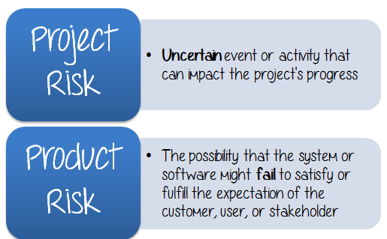](https://www.guru99.com/images/TestManagement/testmanagement_article_2_1_9.png)

## **Step 2) Analyze the impact of the risk occurring**

In the previous topic, we already identified the risks which may hamper your project. Here is the list of risks identified:

* You may not have enough **human resource** to finish the project on the deadline
* The Testing **environment**may not be setup properly like real business environment.
* Your project **budget**may cut by half because of business situation
* This website may **lack** security functions

Next, you should analyse these risks.

Each risk should be classified on the basis of following two parameters

* The **probability** of occurrence
* The **impact** on the project

## **Step 3) Take COUNTERMEASURES to mitigate the risk**

This activity is divided into 3 parts

[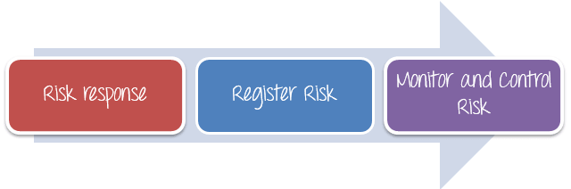](https://www.guru99.com/images/TestManagement/testmanagement_article_2_1_15.png)

## **Risk response**

The project manager needs to choose strategies that will reduce the risk to minimal. Project managers can choose between the following four risk response strategies[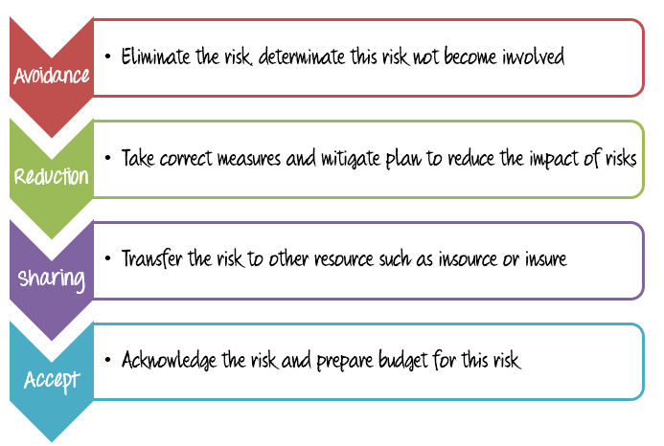](https://www.guru99.com/images/TestManagement/testmanagement_article_2_1_16.png)

## **Register Risk**

All the risk must be recorded, documented and acknowledged by project managers, stakeholder and the project member. The risk register should be freely accessible to all the members of the project team.

There’re some useful to register risk such as [Redmine](http://www.redmine.org/), [MITRE](http://www.mitre.org/publications/systems-engineering-guide/acquisition-systems-engineering/risk-management/risk-management-tools)... etc.

## **Monitor and Control Risk**

Risks can be monitored on a continuous basis to check if any changes are made. New risk can be identified through the constant monitoring and assessing mechanisms.

**How to Review the Software Requirements?**

* Make sure that all team is participating in the Software Requirements Specification Document Review and read specification document carefully and discuss each and every point with your team members.
* Do not assume any requirements; if any requirement is unclear then you should raise the queries. Example, if one input field is accepting amount greater than 10 and less than 100. So here you can ask about are we going to support decimal points for this filed, if yes then how many places.
* If any unclear specifications, make sure that all queries should be resolved from the Product Manager as soon as possible.
* Make sure that all question/queries/pending issues should be tracked under issue tracker (you can also track this in simple excel as well). Make sure that capturing each and every question in the tracker and make sure that it should get resolved from the Product Manager or Program owner.

**What is RTM and purpose of RTM?**

**Requirement Traceability Matrix (RTM)** is a document that maps and traces user requirement with test cases.

The main purpose of Requirement Traceability Matrix is to validate that all requirements are checked via test cases such that no functionality is unchecked during Software testing.

## Types of Traceability Test Matrix

In Software Engineering, traceability matrix can be divided into three major components as mentioned below:

* **Forward traceability**: This matrix is used to check whether the project progresses in the desired direction and for the right product. It makes sure that each requirement is applied to the product and that each requirement is tested thoroughly. It maps requirements to test cases.
* **Backward or reverse traceability:** It is used to ensure whether the current product remains on the right track. The purpose behind this type of traceability is to verify that we are not expanding the scope of the project by adding code, design elements, test or other work that is not specified in the requirements. It maps test cases to requirements.
* **Bi-directional traceability (Forward + Backward):**This traceability matrix ensures that all requirements are covered by test cases. It analyzes the impact of a change in requirements affected by the[Defect](https://www.guru99.com/defect-management-process.html)in a work product and vice versa.

**What is ALM in manual testing?**

**ALM** stands for Application Lifecycle Management. **ALM** Quality Center (QC) is the set of tools used along with **manual testing** to keep record of your **test** process, execution, results, etc. **ALM** is essentially the process of managing an application from its inception to its demise through all phases of the SDLC.

Test Plan:

1. Scope/Aim- Description about the project and features to be tested and not tested.

2. Test Approach- Describes the various activities and way of working involved in the execution.

3. Test Environment- Test bed where the testing takes place.

4. Test Methodology- Methods that are used to test the Functional and Non Functional requirements.

5. Roles and Responsibilities

6. Risk-

7. Mitigation Plan- The process of developing options and actions to enhance opportunities and reduce threats to project objectives.

8. Test Deliverables- Test artifacts and Test execution oriented documents are given to Stakeholders of the Software project.

9. Test Automation

10. Effort Estimation- It gives the details of Cost, Time taken and Resources involved.

11. Entry and Exit criteria